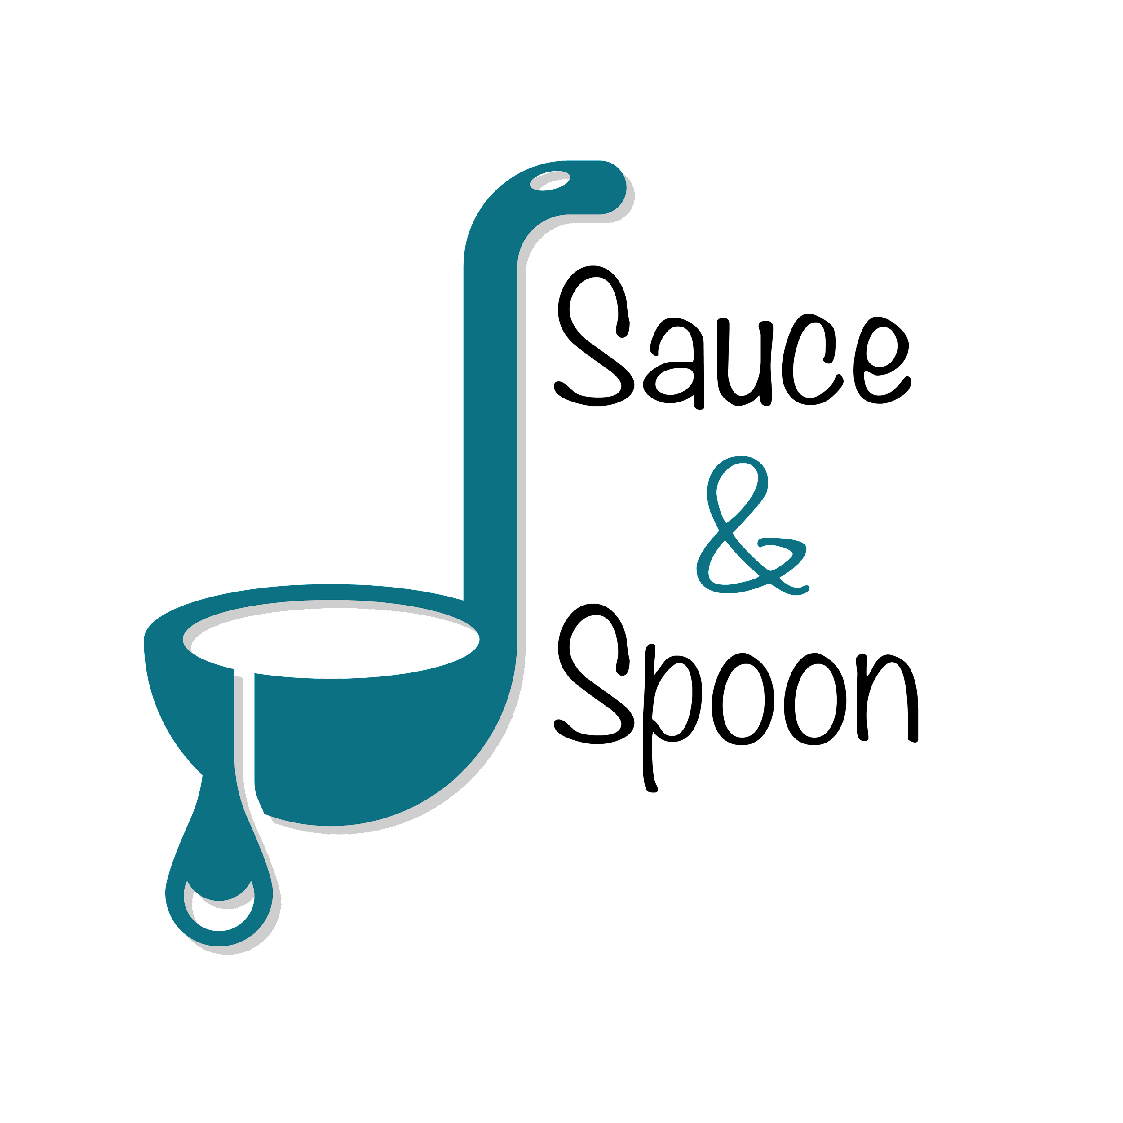

Project Charter: Tablet Rollout Pilot

DATE: [05/01/23]

| **Project Summary** |
| --- |
| Sauce & Spoon is a local restaurant chain specializing in scratch-to-table cuisine and committed to partnering with local farmers and suppliers. The restaurant group is growing in annual sales (+28%) each year and wants to meet demand by improving current restaurant operations. We will accomplish this by launching a pilot rollout of tabletop menus in the bar area at two of the restaurant’s locations: Sauce and Spoon North and Sauce and Spoon Downtown at the beginning of Q2. |

| **Project Goals** |
| --- |
| * Implement tablet menus by the start of Q2 to improve operations * Decrease average table turn time by 30 mins resulting in a decrease in customer wait time and an increase in average guests count by 10% by end of Q2 * Increase average check total from $65 to $75 by selling more appetizers and beverages by the end of Q2, resulting in increased profits * Cut food waste by 25% by end of Q2 by using the tablet to communicate specific guest requests to the kitchen directly resulting in a reduction of prime cost * Increase appetizer sales by 15% on average by the end of Q2: North location 10% and Downtown location 20% * Implement staff training by the end of Q2 so that the staff is comfortable with the new technology * Seamless integration of the tablet software with the existing POS and host software by end of Q2 |

| **Deliverables** |
| --- |
| * Collect clear data points to track metrics   + The tablets will track table turn time and ordering trends which will help to ensure restaurants success * Develop and implement a training program to train staff on the new technology * Install the tablets in the bar area in both the locations   + North   + Downtown * Configure tablet software to be compatible with the existing host and POS software * Implement tablet feature to promote specific item   + Suggest any item as an add-on   + Display coupons for selected items |

| **Scope and Exclusion** |
| --- |
| **In-Scope:**   * Pilot tablet rollout in two locations: North and Downtown * Tablet rollout in bar section of each location * Food waste management * Train staff on tablet technology * Increase appetizer sales * Increase check total   **Out-of-Scope:**   * Policy change on order returns * Kitchen staff satisfaction |

| **Benefits & Costs** |
| --- |
| **Benefits:**   * Meet the rising demand of customers by improving operations * Increase in revenue by increasing the check average * Reduction of costs by reducing food waste * Increased customer satisfaction and loyalty * Reduction in burnout rate by increasing staff satisfaction * Enhanced service resulting in more customers and less wait times   **Costs:**   * Training materials and fees   + Estimated cost: $10,000 * Hardware and software Implementation across locations   + Estimated cost: $30,000 * Maintenance(IT fees through EOY)   + Estimated cost: $5,000 * Updated website and menu design fees   + Estimated cost: $5,000 * Other customization fees   + Estimated cost: $550 |

| **Appendix:** |
| --- |
| * Misalignments:   + Reallocate payroll to hire more kitchen staff     - The team could not agree whether to reallocate payroll to hire more kitchen staff   + Hiring new employees - BOH or FOH? Additional data required from Alex and Gilly to confirm   + Initial misalignment on increase in appetizer sales - reached a compromise of 15% increase   + Measuring kitchen staff satisfaction - Carter will provide specific metrics on how to measure employee satisfaction   + Should implementing policy changes be a part of the tablet rollout? Carter suggested policy changes as a result of order returns due to return. Need to discuss specifics |